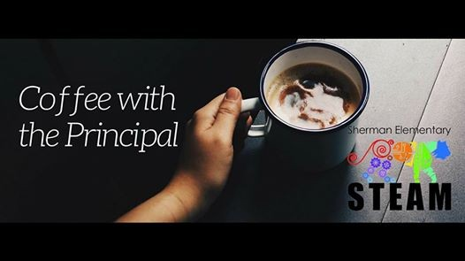
This is a great opportunity to learn what is happening at Sherman Elementary, ask questions, and meet fellow Sherman parents while enjoying a cup of coffee or tea with Principal Anne Tsuneishi. A Sherman PTSA board member is always available to provide updates on PTSA happenings and answer questions too!
These get togethers are generally the 1st Friday of every month, unless there is no school that day, and are located in the "Ohana Cafe" (also known as Mrs. Edmond & Mr. Wise’s classroom). Stop by after you drop off your child!

